Homework for Chap 2
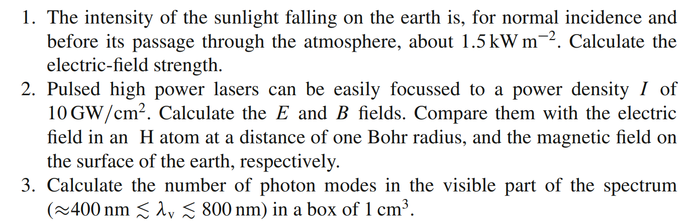
4. Derive the density of states for electrons in a 3-dimensional semiconductor

